

**Dolgin Debuts 4-Position Smart Battery Charger** **for** **JVC GY-HM600/650 Cameras** April 22, 2013

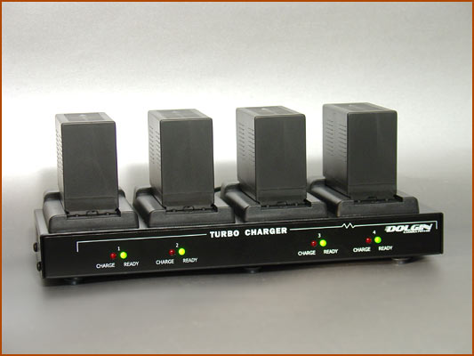**Lexington, MA** - Dolgin Engineering is expanding its line-up of 7.2V battery chargers by introducing the “FOUR ZERO” (TC40-JVC-650), a fast 4-position microprocessor based battery charger for SSL-JVC50 and SWIT S-8I50 battery packs.  
Designed for field newsgathering operations, video production studios and rental facilities, the unit is designed to provide fast, reliable charging of multiple camera batteries for both in-house and field use.   
  
According to company president Alex Dolgin, who designed the charger, the TC40-JVC-650 incorporates a host of key features including:

* Fast, safe simultaneous charging.
* Each of the 4 channels is fully independent of the other.
* Worldwide 100-240V AC or 12v DC power for mobile use, using cigarette lighter car cord for connection to the power source.
* Sleek, small and lightweight package 10.5"x 4"x 1.5"
* Designed and manufactured in the USA.
* Warranty 2 years.

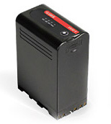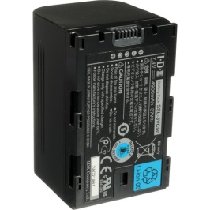The FOUR ZERO also features a highly efficient smart charging circuit. “It takes only about 4.5 hours to charge a SSL-JVC50 battery pack. The pack can be left on the charger after the charge is complete,” said Dolgin.   
  
The design of the charger he said, utilizes unique Dynamic Power Management (DPM) technology for minimizing battery charge time. By dynamically adjusting battery charge current, more current is allocated to the deeper discharged batteries. Through this process the batteries are ready to use at about the same time.   
For more information visit Dolgin [www.dolgin.net](http://www.dolgin.net) or call 781 863-1813